**Commodore 1541-II VIA/Parallel-Adapter Rev. 0**

**Module Description**

# Introduction

This adapter board serves as a VIA (6522) adapter for a parallel connection for SpeedDOS in conjunction with a suitable ribbon cable and the User Port Parallel-Adapter (Project 150).

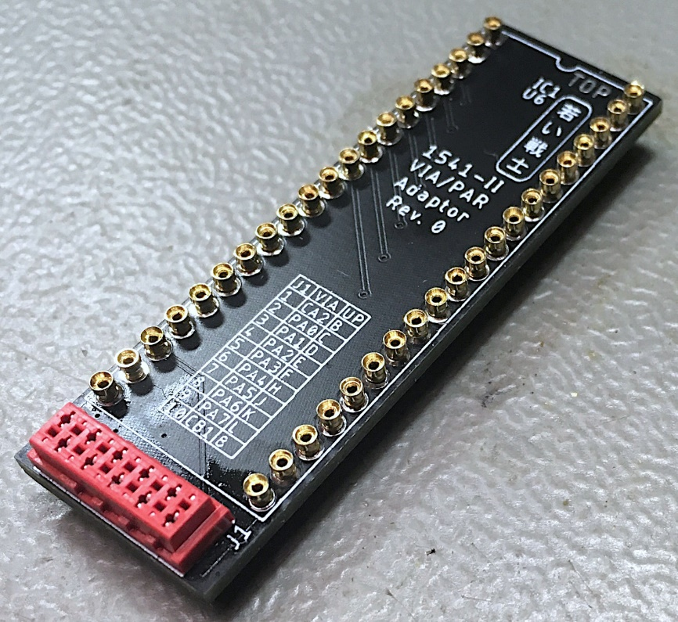

Figure 1: Commodore 1541-II VIA/Parallel-Adapter

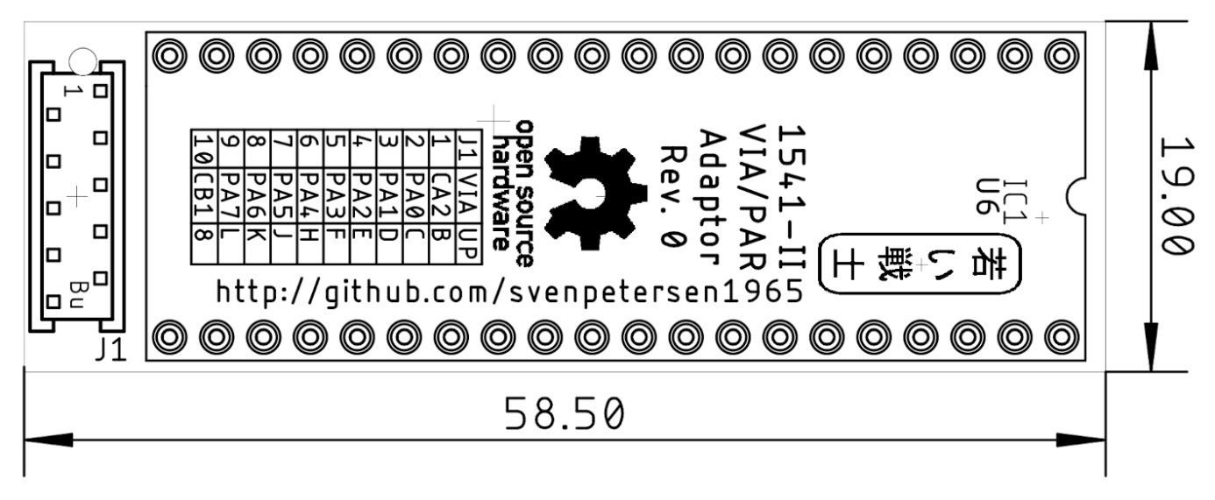

Figure 2: Dimensions

The microMatch connector (10 way) has the following pinout:

|  |  |  |  |
| --- | --- | --- | --- |
| **VIA (pin)** | **J2** | **J2** | **VIA (pin)** |
| CA2 (39) | 1 | 2 | PA0 (2) |
| PA1 (3) | 3 | 4 | PA2 (4) |
| PA3 (5) | 5 | 6 | PA4 (6) |
| PA5 (7) | 7 | 8 | PA6 (8) |
| PA7 (9) | 9 | 10 | CB1 (18) |

The via for the parallel data transmission in a 1541 is U6.

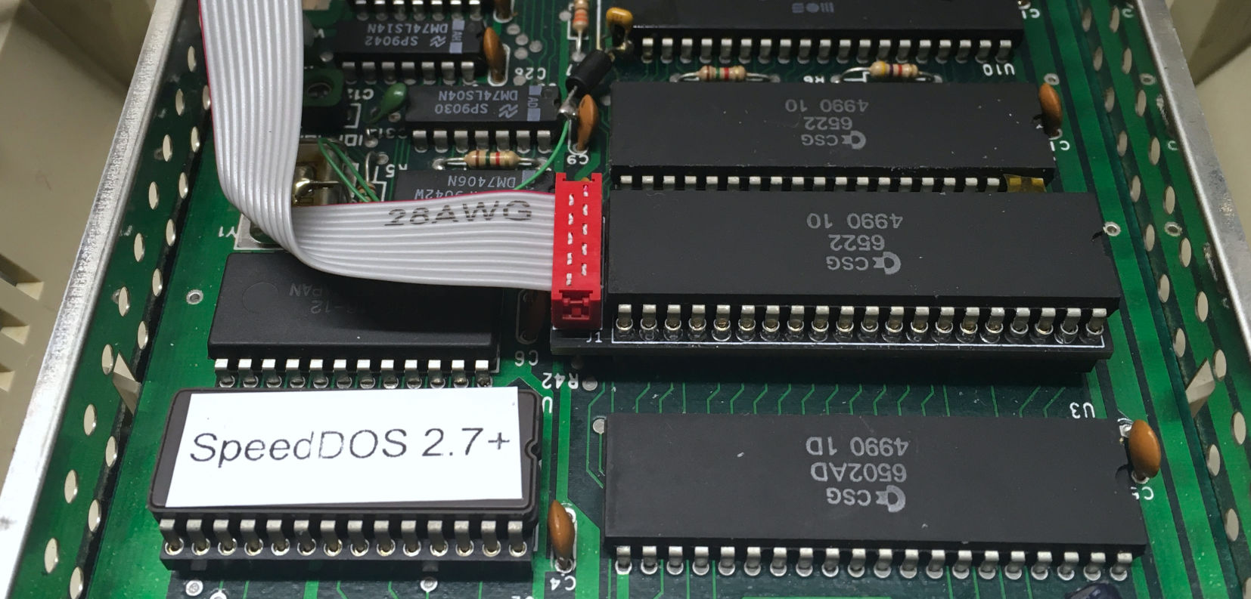

Figure 3: VIA-Parallel-Adapter installed in a 1541-II

# Installation

Four issues have to be taken care of, when installing the VIA-Parallel-Adapter:

* The VIA (U6) should be socketed
* The adapter has to be oriented properly (align the notch of the IC, the adapter and the socket on the 1541-II PCB
* The pins of microMatch connector on the solder side must not make contact with any component leads.
* Pin 2 (PA0) of U6 is connected to GND, which is not required for proper operation (not even with the original Kernal!). **This prevents a proper function** of the parallel adapter. Pin 2 must either be cut off, filed down (a bit) and insulated (Figure 4) or the trace between pin 1 and pin 2 of U6 must be cut.

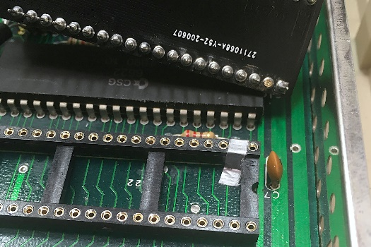

Figure 4: Shortened pin 2 and insulated socket

It is a good idea to secure the ribbon cable with an adhesive cable post and a cable tie for strain relief, after the configuration is fully functional. A ribbon cable exiting the case through the breakout for the fuse is pretty common, I did not experience any problems with it, but one person reported a possible source of problems, here.

An alternative way of exiting the case is the left side of the case. A breakout for the ribbon cable has to be filed into the case, though.

The cable making with IDC connectors does not require any special tools, except a (small) vice for compressing the connector after the ribbon cable was inserted properly. In case you don not feel comfortable with this work, consult this write up about cable making: <http://tech.guitarsite.de/cable_making.html#Ribbon%20Cables>

# Assembly

The low-profile property of the adapter requires precision round pin sockets. They are usually pretty hard to source and expensive. In July 2020, they were about $10 plus shipping for 50 each on Ebay USA. It is pretty cheap and easy to salvage them from a precision pin DIP-40 socket (40 pin sockets for less than $1!). The pin sockets can be popped out of a precision pin socket by applying slight pressure from the bottom side on the “shoulders” of the pin socket with a suitable tweezer (Figure 5). This takes less than 2 minutes per 40 pins.

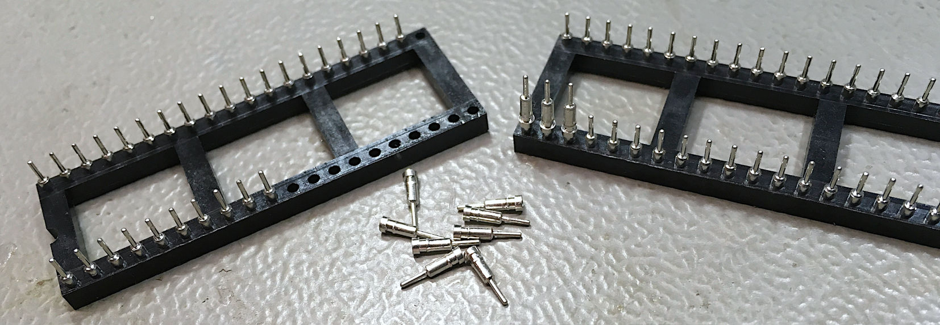

Figure 5: Salvaging the pin sockets

For proper soldering, the pin sockets need to be aligned. This is accomplished by plugging each on the pin side of a 2nd DIP-40 precision round pin socket (Figure 6). It has t be checked, that all pins are fully inserted. The pins can now be inserted into the solder pads of the PCB from the top side.

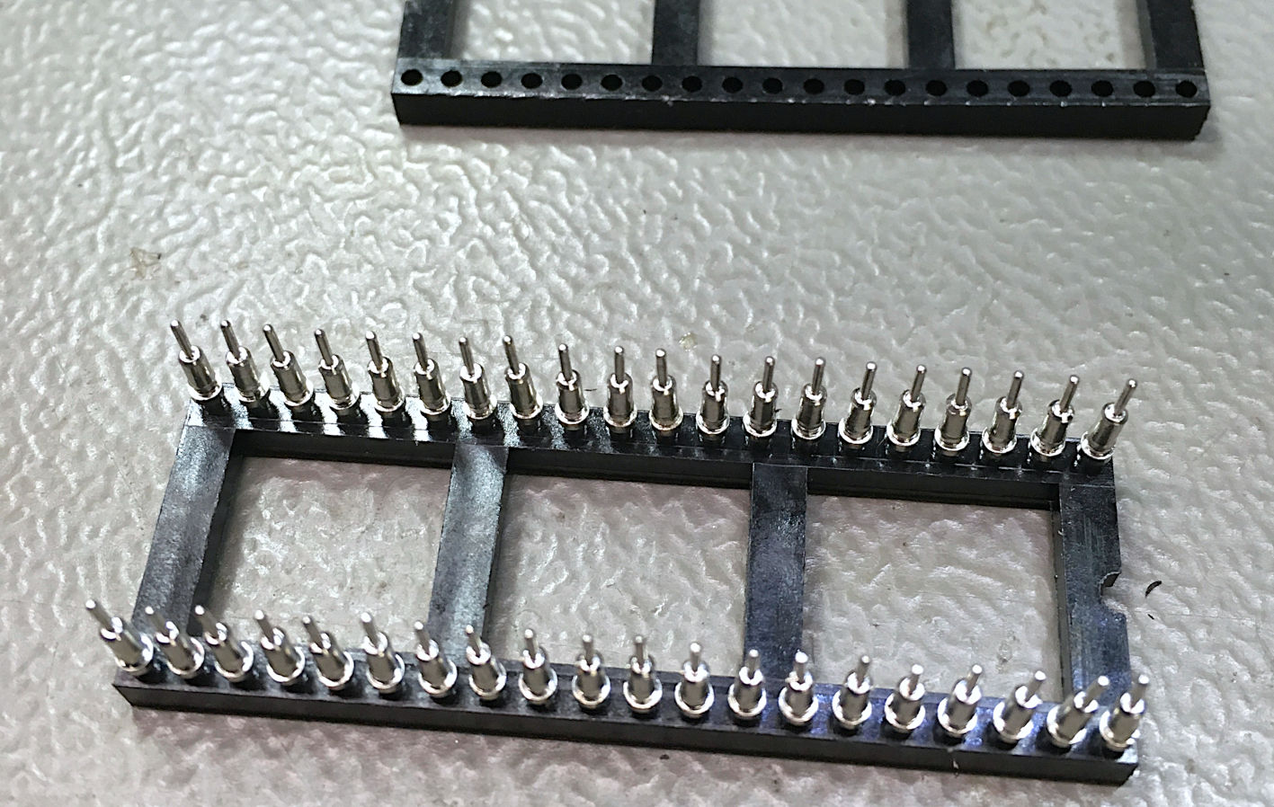

Figure 6: Alignment of the pin sockets

After making sure, that everything is straight (Figure 7), the pins can be soldered from the solder side.

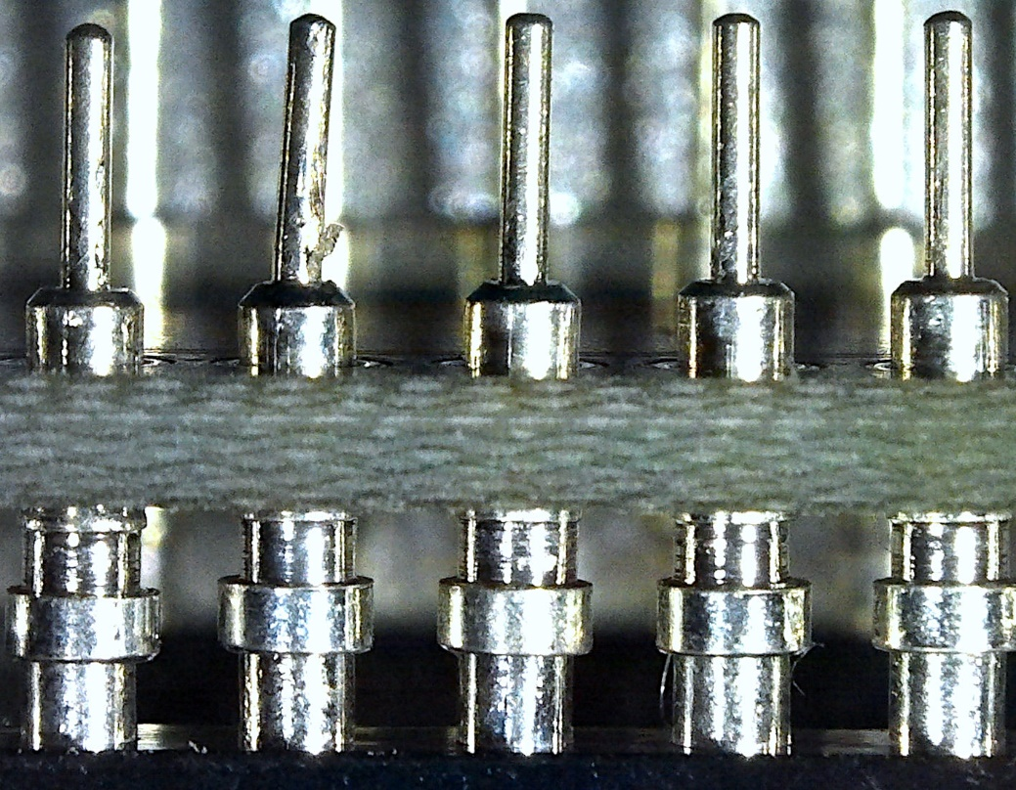

Figure 7: Pin sockets aligned in PCB before soldering

Just add very little solder, so that it just coats the gap between pin socket and solder pad and a meniscus is formed. A smooth, concave meniscus indicates a good wetting (Figure 8).

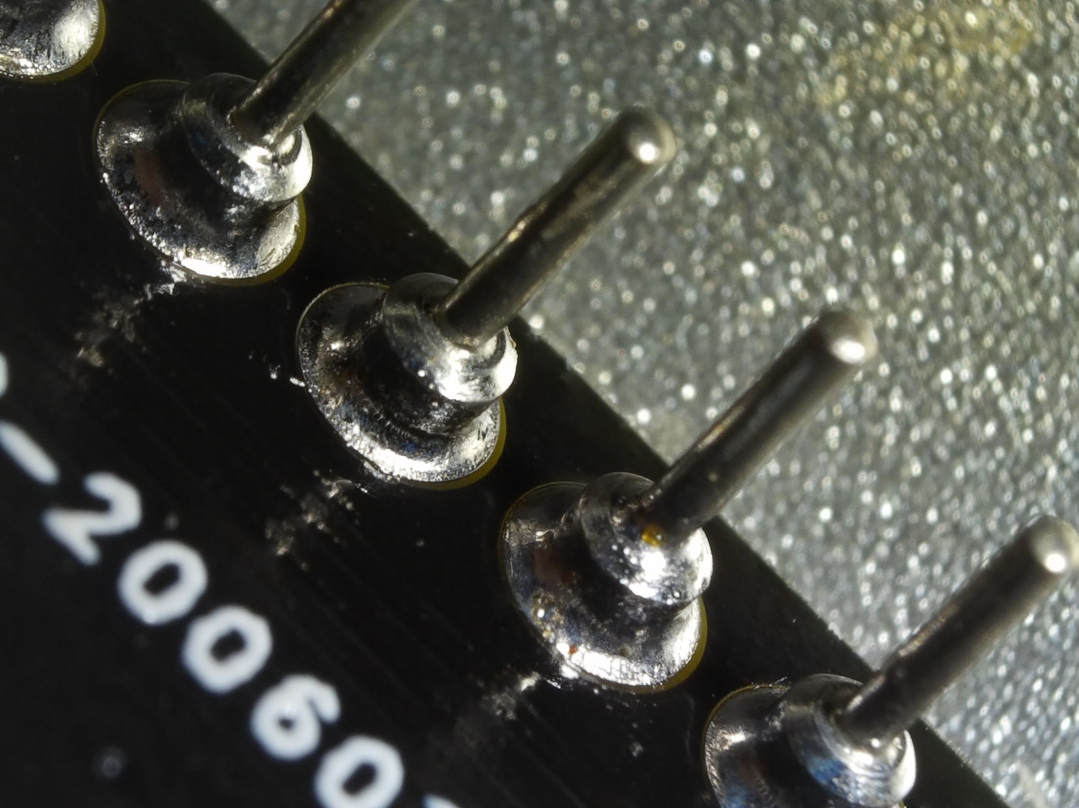

Figure 8: Amount of solder and meniscus of the bottom pads

It is desired that the solder is rising through the pad and also forms a meniscus on the component side (Figure 9). Care must be taken, that the shoulder of the pin sockets is not coated with solder.

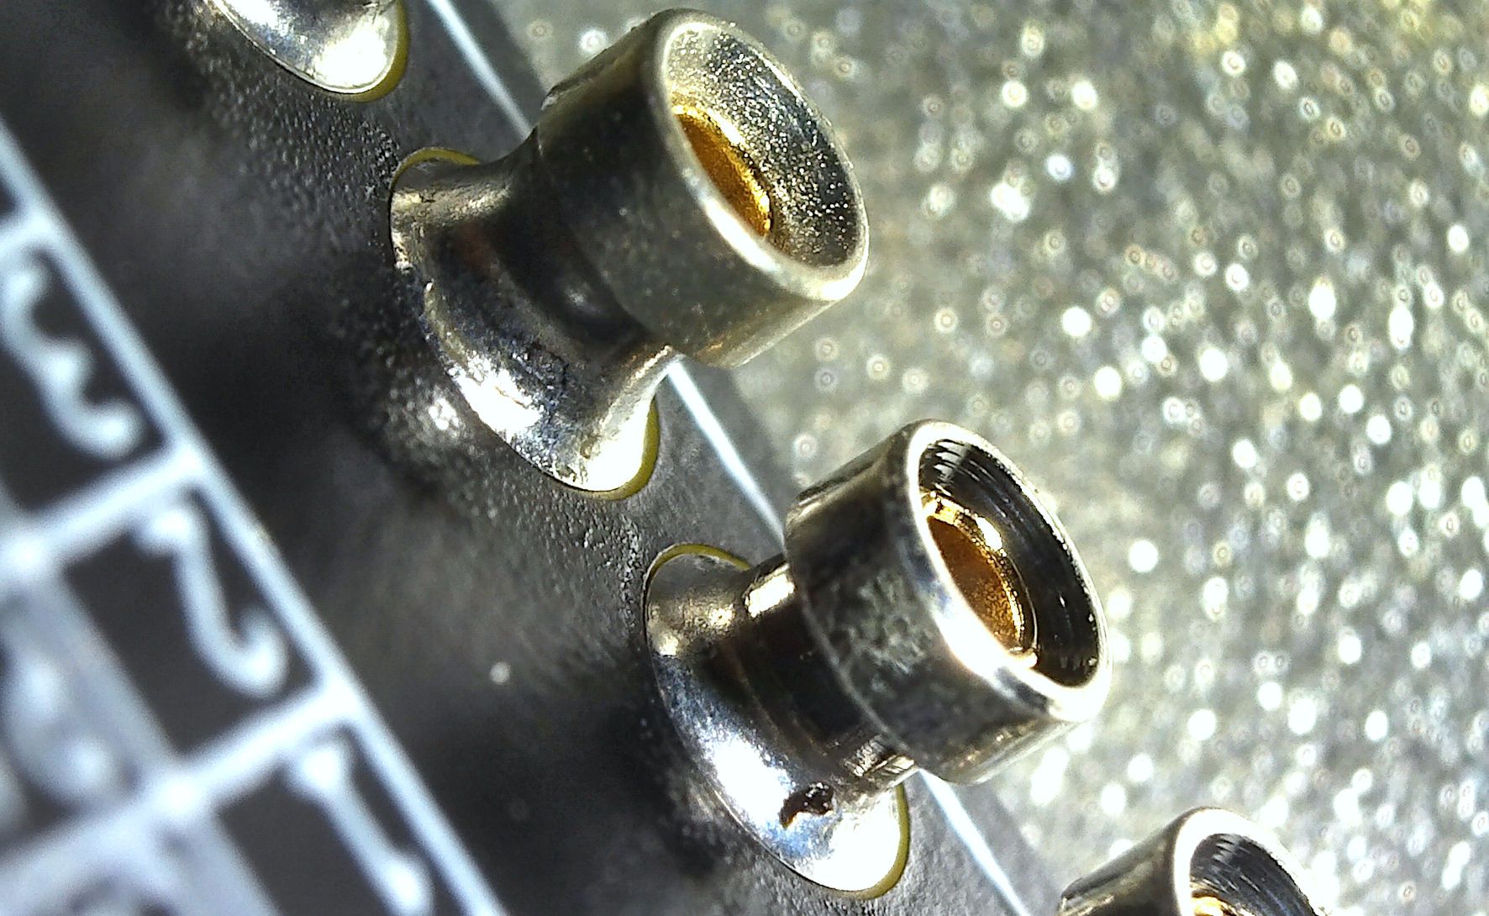

Figure 9: Solder meniscus on the top solder pads

Finally, the microMatch connector can be soldered.

# Revision History

## Rev. 0

* Prototypes fully functional. For testing consult the documentation of the User Port/Parallel Adapter (Project 150).